Republic of Malawi
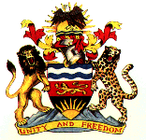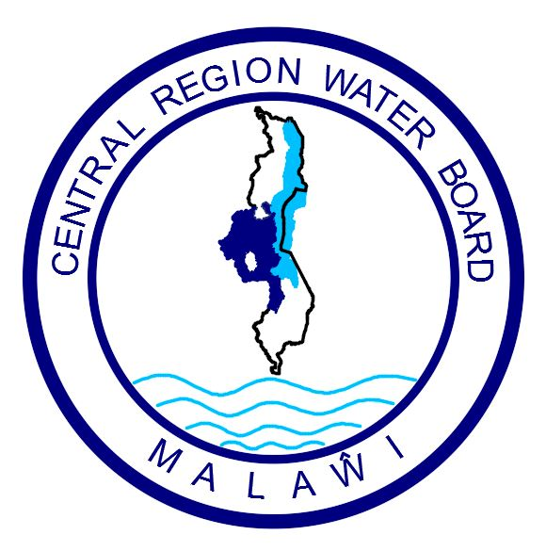

Ministry of Defense | Central Region Water Board

Invitation For Bids - National Competitive Bidding (NCB)

IFB Title: Construction of a Retaining Wall and Upgrading of the Intake Weir at Mvera Support Battalion Raw Water Intake in Dowa.
IFB Number: CRWB/W/MV/02/2022

- The Central Region Water Board has received some funds from Malawi Government through the 2022/23 National budget allocation under the Ministry of Defense and intends to apply part of the funds towards payments under the procurement contract for Construction of a Retaining Wall and Upgrading of the Intake Weir at Mvera Support Battalion Raw Water Intake.

The works comprise of :
- Construction of a 35 x 6 metres retaining wall along the river bank to protect the intake facility from hazardous floods ; and
- Upgrading of a 30 metres long intake weir on the Lilongwe River.

- The Board now invites sealed bids from eligible and qualified bidders who must be registered with National Construction Industrial Council (NCIC) in the 1 Billion Malawi Kwacha or above Civil Works category.

- Bidding will be conducted in accordance with the open tendering procedures contained in the Public Procurement Law and Regulations of the Government of Malawi.

- Interested eligible bidders may obtain further information from and in respect of bidding documents at the address at (10) (a) Attention: The Procurement and Disposal Manager.

- A complete set of Bidding Documents in English may be purchased by interested bidders upon payment of a none refundable fee of Ten Thousand (MWK10,000) Malawi Kwacha by cash or Bank Certified cheque payable to Central Region Water Board.

- Bids must be delivered and deposited in a Tender Box that will be located at the Reception on or before 14:00 hours on 24rd February 2023 clearly marked with Invitation for Bids Number (IFB No), as indicated above.

- Bids will be opened at Central Region Water Board Conference Room in the presence of bidders` representatives who may choose to attend on 24rd February 2023 at 14.00 hours local time. Late bids will be rejected.

- Site visit and pre bid meeting will not take place at Mvera Support Battalion Raw Water Intake Plant in Dowa on 03.02.2023 from 09.00 hours. Bidders will however make their own travel arrangements to and from the site.

- Central Region Water Board reserves the right to reject any or all bids and is not bound to accept the lowest or any other bidder.

- Addresses referred to above are:

- For Inspection, Clarifications, and Purchase of Bidding Documents:

Attention: Mr Simeon Banda - Procurement and Disposal Manager
Central Region Water Board Offices
Area 4, Murry Road
Opposite Immigration Offices
Private Bag 59
Lilongwe
Malawi
Phone No: 01 758 044 / 045/ 046
Cellphones: 0888 395 162 / 0998 570 437
Email: crwb@crwb.org.mw / sbanda@crwb.org.mw

- For Submission of Bids:

The Chief Executive Officer
Attention: Internal Procurement and Disposal Committee
Central Region Water Board
Area 4, Murry Road
Opposite Immigration Offices
Private Bag 59
Lilongwe
Malawi

